What We Heard

Workers’ Compensation Act
PTSD Presumption
and
Support for amendments to the
Occupational Health and Safety Act

Summary of public consultation
June 5 – 30, 2017

Background
The Yukon Government committed to amending the Workers’ Compensation Act to include a post-traumatic stress disorder (PTSD) presumption for emergency response workers. On behalf of the government, Yukon Workers’ Compensation Health and Safety Board (YWCHSB) recently conducted a public consultation to collect public input on the following two issues:
- The Workers’ Compensation Act will be amended in 2017 to provide a PTSD presumption for emergency response workers which will apply to firefighters, paramedics and police officers. The government wants to know what other occupations the public thinks should be considered in the future.

- The government also wants to know if the public would support amendments to the Occupational Health and Safety Act to promote the development of regulations aimed at preventing mental injuries at work.
A two-question survey was published on the YWCHSB website. Interested Yukoners could respond using a form on YWCHSB’s website, via email, or in print format.
YWCHSB advertised the survey through the Yukon government staff newsletter, in newspaper and radio advertisements and online. YWCHSB’s regular stakeholder groups were directly invited to provide submissions. The consultation period ran from June 5 to June 30, 2017.
In total, 206 Yukon citizens and organizations responded to the survey. One hundred and ninety-four responded to the on-line survey and 12 provided written submissions.
This document provides an overview of what we heard.

What We Heard
Question One
The Workers’ Compensation Act will be amended to provide a PTSD presumption for emergency response workers which will apply to firefighters, paramedics and police officers. Are there other occupations you think should be considered in the future and why?
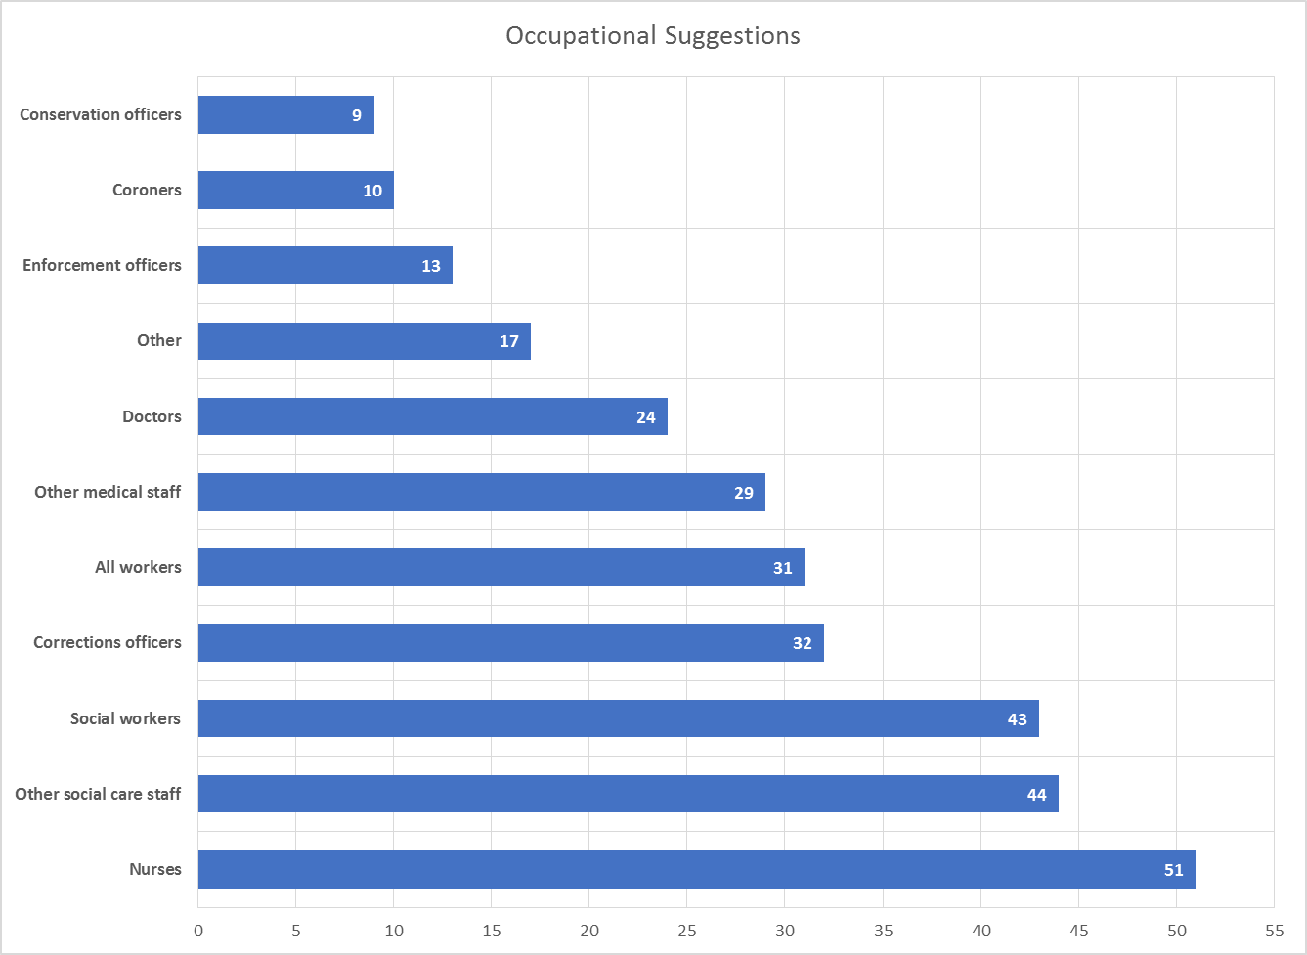
See appendix for a breakdown of job titles included in occupational groups.
Overview of responses
76% of respondents—157 of 206—suggest applying the PTSD presumption to a broader group of occupations. The three occupations or occupational groups most commonly suggested for inclusion were nurses, social workers and other social care staff, and corrections officers. About 16% of respondents suggested the presumption should apply to “all workers.” Three respondents felt that the proposed amendment should be limited to the occupations currently included in the definition of “emergency response worker” (firefighters, paramedics and police officers).
Nurses
Many of those in favour of applying the presumption to nurses recognize the often front-line nature of nursing, such as providing emergency services in rural Yukon. We heard that flight nurses frequently fly into trauma situations, and that emergency room nurses may develop PTSD from providing front-line emergency care. Numerous submissions indicated that nurses are regularly exposed to direct and vicarious trauma in treating traumatic injuries and being victims of violence. Here is one comment:
“Nurses must be included from the outset, as their work exposes them to direct and vicarious trauma regularly. In hospitals and ERs, Nurses are regularly exposed to violence from patients and traumatic injuries they must treat. Studies have found that nurses experience high frequency of PTSD and compassion fatigue.”
Social workers
As an occupational group, social care staff include many jobs such as child protection workers, youth-at-risk workers, mental health and addictions counsellors, and therapists. (See the Appendix for a complete list). We heard from those in favour of adding such workers to the presumptive legislation that these workers are regularly exposed to direct and vicarious trauma, through removing children from their homes, being victims of assault, and constantly hearing about traumas suffered by their clients. A compounding factor mentioned by several respondents is that many of these workers are alienated within their communities, as their jobs make them vulnerable to criticism and even personal attack. Some expressed concerns that isolation and lack of community support contribute to the potential development of mental health injuries. These excerpts reflect those opinions:

“Anyone working with at risk populations. For example, group home workers, probation officers etc. We are all affected by vicarious trauma. Our clients are harmed, die, victims or offenders of horrific situations. Hearing these traumatic stories day in and day out becomes a burden on our own mental health.”
“I think that social workers working within child protection should be included in the changes. I say this as the nature of the work can expose workers to situations that are traumatic in and of themselves, such as, removing children from the care of their parents. They also are exposed to other peoples’ traumas regularly. Generally, like police officers they do not deal with people on their best days. To the contrary, these interactions are often part of the worst days of the clients’ lives.”
Gender equity
This submission identified a possible gender equity issue related to the proposed PTSD presumption:
“Various research indicates that worker occupations generally considered for presumptive PTSD provisions tend to be male-dominated. Occupations that tend to be female-dominated, such as nursing and child protection / social service work, where there is regular (direct or vicarious) exposure to trauma and violence, are not being recognized for the degree of trauma risk and potential harm associated with the work. This concern is heightened by the fact that gender appears to be a predictor of PTSD incidence rates, with more women than men meeting criteria for both full and partial PTSD.”
A similar response invited the government to consult with the Women’s Directorate before making a decision on the definition of “emergency response worker.”
Corrections officers
One respondent in favour of adding corrections officers suggested:
“Correctional officers should be considered. As a correctional officer I witnessed and experienced many traumatic incidents during my employment. After 12 years of working this job with only limited EAP hours available and no other support, I had to quit my job. I believe if this position was included in the above mentioned group, perhaps the employer would address the mental well being of their workers to a greater extent and it would also give the worker an option other than quitting and experiencing hardships to aid in recovery.”

A broader approach
The following excerpts suggest the government is taking too narrow an approach:

“...simply apply the PTSD-presumption provision to all persons providing emergency services, without specifically identifying them by profession or occupation.”
“...restricting this easier access to three groups of emergency response workers and then only to those who demonstrate the most serious mental trauma, PTSD, on the continuum of medically recognized mental injuries to which emergency response workers are more susceptible to than other workers is too small a step in Yukon’s emergency response context.”
“...we must take a “made in the Yukon” approach to defining “emergency response workers”. The amendments must go beyond the occupations listed in the question to include other Yukon workers who regularly respond to emergencies because of the unique aspects of living in the north.”
The responses to this question indicate that many people misunderstand the concept of a PTSD presumption. While PTSD coverage extends to all Yukon workers, many respondents believe that YWCHSB’s current psychological injury coverage either does not extend to their occupation or is inadequate in some way.
To sum up
In summary, three of the 206 respondents (about 1%) believe no other occupations should be considered beyond the three proposed by the government (firefighters, paramedics and police officers). The majority of respondents—76%—want more occupations considered for inclusion. The most commonly suggested additions are nurses, social workers and other social care staff, and corrections officers. About 16% of respondents believe all workers should be covered by a PTSD presumption.

What We Heard
Question Two
Would you support amendments to the Occupational Health and Safety Act to promote the development of regulations aimed at preventing mental injuries at work? What are the benefits and disadvantages of this approach?
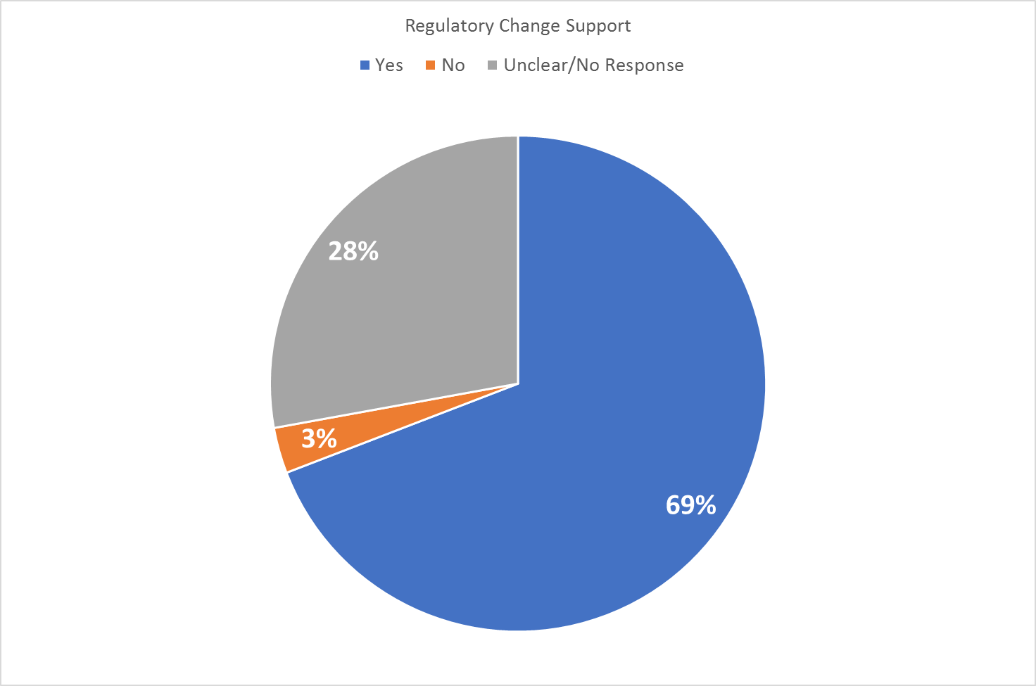
As shown in the pie chart, 69% of respondents support amendments to the Occupational Health and Safety Act (OHS Act) to promote the development of regulations aimed at preventing mental injuries at work.
A few dominant themes emerged in support of amendments to promote prevention:
- Prevention is more effective than treatment. Many respondents believe that treating mental health conditions is difficult and costly. Preventing the development of disorders in the workplace would be more cost effective over the long term.
- Mental health issues have far-reaching effects that go beyond the workplace.
- Yukon has a small workforce and difficulties are often encountered in replacing workers. These comments focused on the cost benefit of retaining employees vs. use of sick and disability leave for mental health issues.
- Regulations supporting prevention would help reduce the stigma attached to mental illness.
The following excerpts outline why some respondents believe these amendments are important:
“These amendments are critical to health and safety of Yukon’s workers. While presumptive legislation is important to assist workers in at-risk jobs, prevention is even more critical. It is better to ensure that work is psychologically safe, with proper supports to prevent or mitigate mental injuries, than to only help sufferers after the fact.”
“Prevention is essential, otherwise these kinds of claims are going to spiral out of control. Employers must have a psychological health and safety management system/plan/standard looking at prevention of mental injuries at work.”

“Yes, I would support this, as some of these injuries could be prevented with early intervention or immediate support provided once a worker expresses that they are struggling and/or exposed to a particularly difficult event for them. These regulations may assist the employer to gain further knowledge and respond in a more timely manner.”

Many respondents were not sure whether they would support amendments to the act. They wanted more information on what the regulations would look like before commenting on whether they would support them.
One offered:
“...it would be helpful if the Board could offer stakeholders further details on the specific legislative amendment proposals it has in mind to address mental health injury prevention. This would enable stakeholders to provide better-informed and focused input on the contemplated amendments.”

A minority of respondents do not support legislative amendments. Among the reasons given were:
- Potential expense for employers to implement prevention programs.
- Potentially higher assessment rates.
- Concern that new regulations would be ineffective, given the perceived lack of compliance with existing regulations.
- Lack of confidence that mental health injuries can be prevented in certain occupations due to the nature of the work.
Some comments from respondents not in favour of OHS Act amendments:
“No. Any regulations you draft will never be implemented. As it is, there are regulations that are never followed. Why would these be? A huge disadvantage would be the cost. This will increase costs for governments, which everyone pays.”

“NO!!! I would be supportive of amendments which would provide REMEDIES and SUPPORTS to those affected by work-place mental health injuries without the affected individuals having to go through ridiculous hoops and feeling the stigma associated with mental health issues. It is NOT realistic to say we can prevent them given the nature of the work that is done. Get real!”

“Using OH&S as a medium to fight or prevent mental illness will not work. Too many people will "cry wolf" and devalue legitimate claims.”

Overall Summary
With respect to proposed amendments to the Workers’ Compensation Act, the majority (76%) of Yukon citizens and organizations who responded to the survey recommended expanding the scope of the presumption to more occupations than the ones proposed (firefighters, paramedics and police officers). The top three suggested additions are nurses, social workers and other social service providers, and corrections officers. About 16% of respondents believe the presumption should apply to all workers. About 1% believe the presumption should be limited to the three occupations proposed by the government.
With respect to support for amendments to the Occupational Health and Safety Act, the majority of respondents (69%) are in favour. Many expressed support based on the human and financial costs of mental health injuries and their far-reaching effects in workplaces and the broader community. The few opposed expressed concerns about potential costs for employers, scepticism that new regulations would be followed, and the unrealistic belief that mental health injuries can be prevented given the nature of certain occupations.

Appendix

Occupational Taxonomy:
A structured taxonomy for use in categorizing occupations in the PTSD presumption consultation report

Medical Occupations
- Nurses
  - Emergency room nurses
  - Emergency Medical Services nurses
  - Community nurses
  - Medevac nurses
- Doctors
  - Emergency room doctors
- Other medical staff
  - Admitting staff
  - Family support staff
  - Medevac personnel
  - First aid volunteers
  - Midwives
  - Dispatchers
  - Emergency Room staff
- Coroners

Enforcement Occupations
- Corrections officers
- Enforcement officers
  - RCMP officers
  - RCMP auxiliary officers
  - Sheriffs
  - Animal protection officers
  - Occupational Health and Safety officers
  - Housing and Public Works officers
  - Rangers
  - Bylaw officers
  - Search and rescue workers
- Conservation officers

Social Care
- Social workers
- Other social care staff
  - Therapists
  - Counselors
  - Group home workers
  - Nursing home workers
  - Child welfare workers
  - Outreach workers
  - Youth-at-risk workers
  - Mental health and addictions workers

Miscellaneous
- Other
  - Caretakers
  - Military personnel
  - Government workers
  - Retail workers
  - Teachers
  - Office workers
  - Legal professionals
  - Security guards

Van Ameringen, M., Mancini, C., Patterson, B. and Boyle, M.H. (2008), Post-Traumatic Stress Disorder in Canada. CNS Neuroscience & Therapeutics, 14: 171-181. Doi: 10.1111/j.1755-5949.2008.00049.x

